Connecticut Academy of PAs  PA of the Year Nomination | 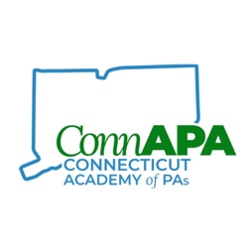

Nominee Information
Name
Mailing Address
City, ST ZIP Code
Phone
E-Mail Address

Purpose

Connecticut has almost four thousand licensed PAs. They work in a variety of practice settings, they volunteer thousands of hours a year, they precept students and they provide exceptional care to the patients of Connecticut and beyond. ConnAPA would like to honor one PA that goes above and beyond by bestowing upon them ConnAPA’s PA of the Year Award. The recipient will be recognized in person, in print, on the ConnAPA website, will be awarded a commemorative plaque, and will be granted a complimentary year’s membership to ConnAPA and complimentary registration to the 2023 Charter Oak Conference.

Eligibility

To be eligible, one must be a licensed PA in Connecticut and practicing for at least five years. It is strongly encouraged that any nominee is a ConnAPA member. Any nominated candidates who are not current ConnAPA members will be informed of their nomination and encouraged to join ConnAPA. There must be evidence of commitment to the profession and community. Examples would be participation in community service, outstanding accomplishments, improving access to healthcare, research developments, and involvement in local, state, or national activities that further the profession. Nominees may not be a current ConnAPA Board Member (Officers and Directors).

Deadline for Nominations/Award Ceremony

The deadline for submissions is March 18, 2022. The award recipient will be selected by the ConnAPA Board of Directors and the award will be presented at the Charter Oak Conference in April, 2022.

Nomination Essay

Please describe why this PA should be awarded PA of the Year.

Submitter Information
Name
Street Address
City ST ZIP Code
Phone
E-Mail Address

Submission

Please return the completed form and any supporting documents or pictures to the ConnAPA office. Submission can be electronic or by mail, but must be received by March 18th. Forms and supporting documentation can be emailed to connapa@ssmgt.com. Paper forms and documentation can be mailed to:
ConnAPA
One Regency Drive
P.O. Box 30
Bloomfield, CT 06002

Thank you for your nomination!

